Preparing and SRS import file from PowerTeacher
In order to use this help document you need to know how to open a blank NotePad, WordPad or MS Word document and save it in a location where you can retrieve it.
On the main screen in PowerTeacher, click on the printer icon for the class you would like to prepare an SRS import file.
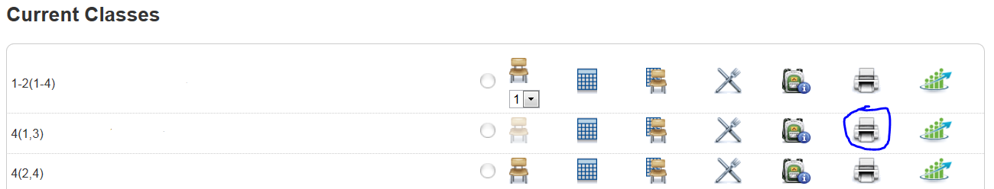
In the Print Class Report window select the “SRS Import File Generator” from the pop up menu for “Which report would you like to print?” and press Submit.
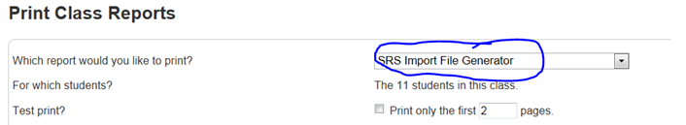

When the file is done click View and then choose to Open the File. Once you see the ID’s and Student names go to the edit menu and choose Select All. Then go to the edit menu and choose Copy.
Open Notepad, WordPad or MS Word and paste the ID’s and names in the blank document. Under the File menu choose Save As and save the document with any filename you want (typically period number) but change the “Save as type:” to a Text Document (*.txt) or if you are using MS Word Save as type Plain Text (*.txt) Example: period1.txt Make sure you save it in the location where you will be looking for your SRS import document when you go to import the students.
The very last step before importing the students is to go to the directory (your documents) and find where you saved the text (.txt) document(s) and change the file extension by right clicking and choosing “rename”. In other words you are going to change the part that reads .txt to .csv so a file called “Period1.txt” will now be called “Period1.csv”. When you make this change you will see a warning message telling you that “If you change a file name extension, the file might become unusable. Are you sure you want to change it?” Click yes. Repeat the process for each class and you will be ready to go through the steps to import your students.
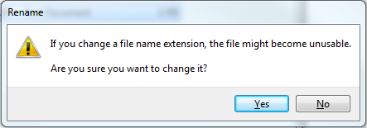

Setting up the Teacher Tools.
Make sure the receiver is plugged in.
Open Smart Notebook 11 (start/all programs/smart technologies folder/smart notebook 11)
Go to Response/Teacher Tools to open up the window seen in screenshot 1 and fill out the fields and click save. The classroom name is what students will see when they sign in on their remotes.
1.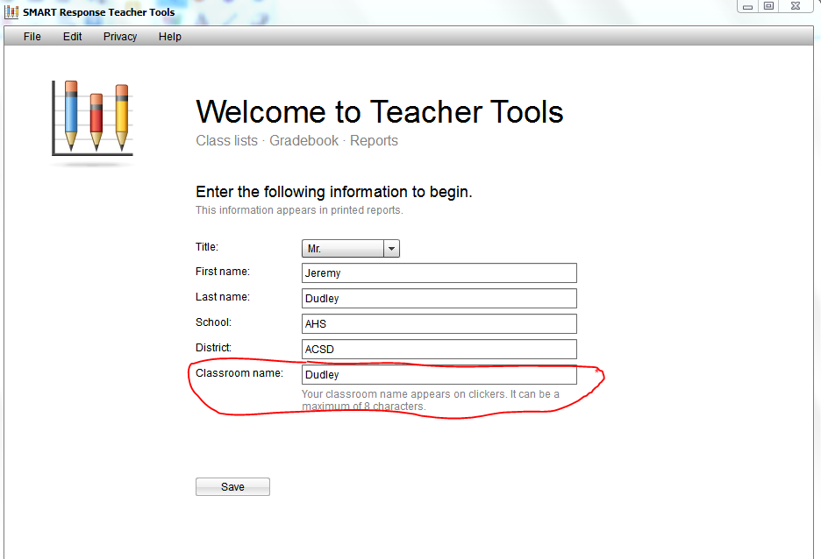
If you don’t see this screen and it goes straight through to your old set up, delete your old classes by clicking on them and deleting them one at a time. You will then be ready to set up your new classes (screenshot 3).

Click Save. This creates the .teacher file in your documents that the computer will look for.
2.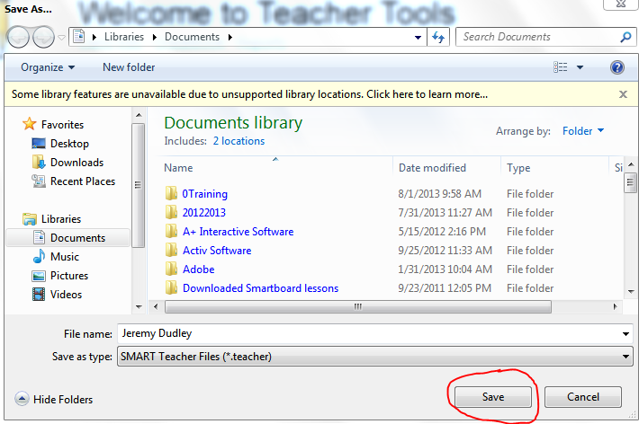
If you ever try to use the SRS and only anonymous mode shows up (which would happen the first time you used it in a new room), go to response/teachertools to launch the window in screen shot 1. Go to File/open and find the .teacher file you just saved. In this example it would be Jeremy_Dudley.teacher

Adding Classes
From the Teacher Tools window click on “Add a class”. (3)
3. 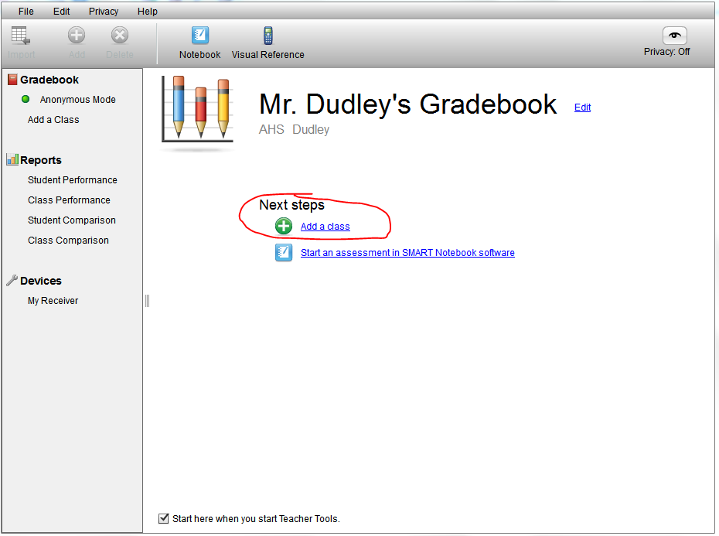

Fill in the fields and click “add”. The passing grade is typically changed to 65%. (4)
4. 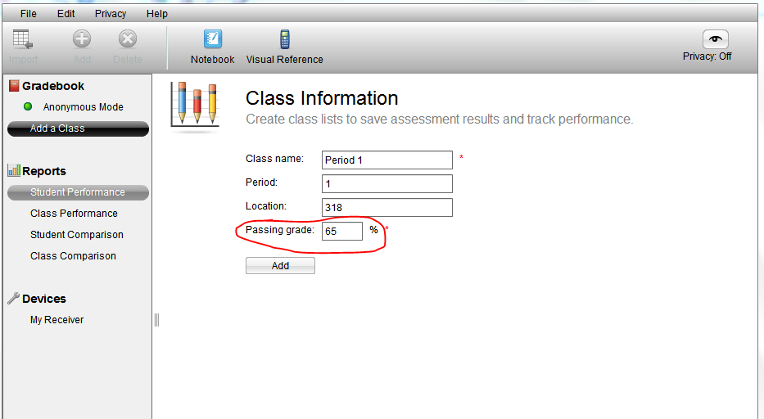
Repeat for each class
Importing Students
From the Teacher Tools window follow the screen shots below. You will already need your classes in a .csv file that you can locate.
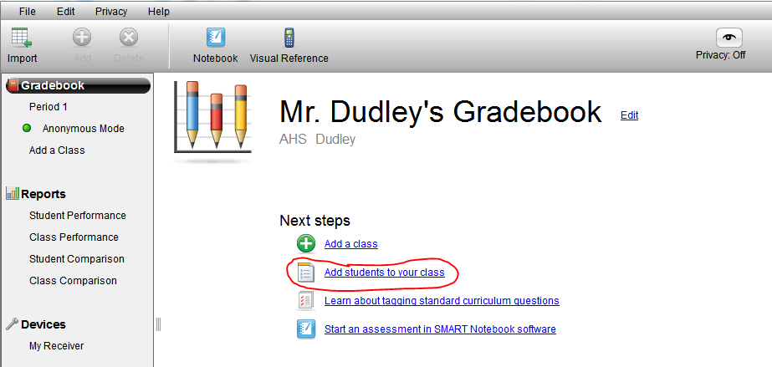
Click “Add students to your class”.
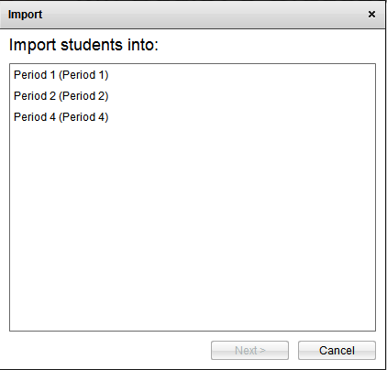
Choose the period you’re importing to.
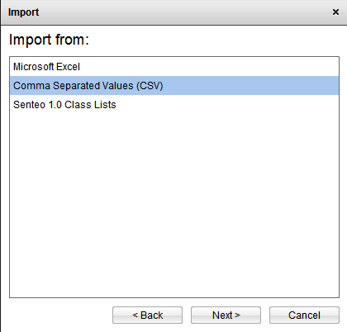
Choose “Comma Separated Values (CSV)”
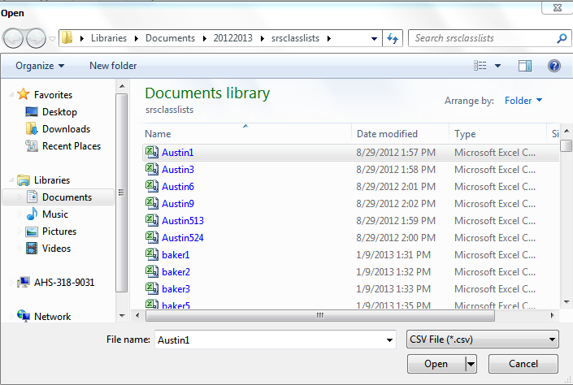
Choose the .csv file for that class and click open. Your students will automatically be added to the period you previously selected.

